# MS Office Excel (Project 1A)

Hey, everyone! Welcome to my first Excel tutorial. Excel is used to organize, collect, and analyze data. It can be either in a workbook or worksheet. A workbook is a file that helps us organize our data. A worksheet is a collection of cells where data is stored and edited. Each worksheet has rows and columns. The rows are labeled with numbers, while the columns are labeled with letters.

I created a worksheet and chart with the data for Pro Fit Marietta. Pro Fit Marietta is a seller of fitness equipment in health clubs, corporate wellness centers, and hotels. The company’s goal is to find, test, and share the highest-quality fitness products in the world to its customers, including its main location in the suburbs of Atlanta, GA. Michelle Barry, Pro Fit Marietta’s president, wants to know the second quarter sales for cardio equipment. So, that’s where the data and chart came in.

I had two options. I could either start fresh with a new blank Excel workbook or use a template. A template is a document with a preset layout or styles for formatting. Instead of creating a workbook from scratch, I can use a template with predefined page layout, fonts, margins, and styles. I chose to create the template. My starting point looked like this:

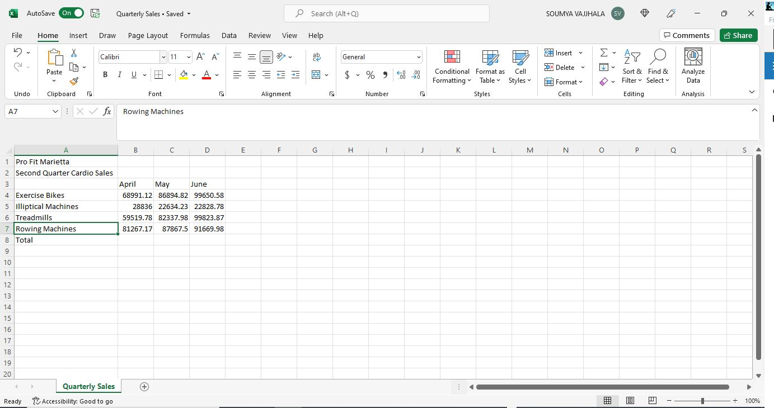

First, I created a formula. A formula calculates the values of cells. It always starts with an equal sign (=). I calculated the sales for April for all four pieces of cardio equipment. So, I used the “SUM” function to add the sales. In cell B8, I typed the following formula:

=SUM(B4:B7)

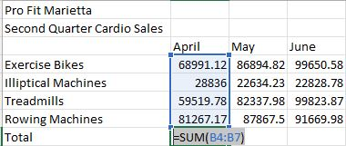

When I pressed “Enter”, cell B8 has a new value, based on the formula I just entered in. I can repeat this step for May and June by manually entering in the formula in cells C8 and D8. But it would take a long time. So, the easiest, quickest way to do this would be to use the fill down tool. The fill handle is a black cross located in the lower right-hand corner of a cell. It lets me quickly copy formulas into adjacent cells by dragging the fill handle. It can either be dragged down vertically or to the right horizontally. When I dragged cell B8 across to cells C8 and D8, the “SUM” formula gets copied over.

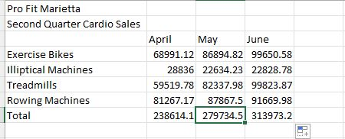

Now that I calculated the total sales for all pieces of equipment for each month, I can follow the same step for each individual piece of equipment for all three months. In cell E3, I typed in “Total”. In cell E4, I have a new formula with the same “SUM” function:

=SUM(B4:D4)

Next, I used the fill down tool to drag and drop the formula vertically down from cell E4 to cell E8. Then, I typed in “Trend” in cell F3.

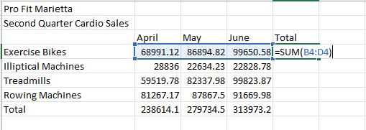

Now that I got my “SUM” formulas in, I formatted my workbook to make it look attractive. I selected the range from cell A1 to F1, navigated to the “Home” tab, went to the “Alignment” group, and clicked on “Merge & Center”. This combines the selected cells into one large cell and the content in the new cell is center aligned. In the “Styles” group, I clicked on “Cell Styles” and chose “Title”. I repeated those steps for the range of cell A2 to F2. But I chose “Heading 1” instead. I highlighted the range from cell B3 to F3 and pressed “CTRL” to select the vertical range from cell A4 to A8. Then, I navigated to the “Home” tab, went to the “Alignment” group, and clicked on “Center”. Then, I applied the “Heading 4” cell style. My next step is to fit my content in my cells. To do this, I clicked on the right isosceles triangle in the upper left-hand corner of my spreadsheet to select the entire worksheet. Then, I double clicked between columns A and B to auto-fit the content in my cells.

Next, I formatted my values in my table to be rounded off to the nearest whole dollar. I selected the range from cells B4 to E8, navigated to the “Home” tab, went to the “Number” group, and clicked on “Currency” in the drop-down menu. This will add a dollar sign to my values in that range. Then, I clicked on “Decrease Decimal” twice to get rid of the two numbers after the decimal point. Next, I set our column widths to auto fit the content. Lastly, I formatted my “Total” row in row 8 for cells B8 to E8 to a “Total” cell style.

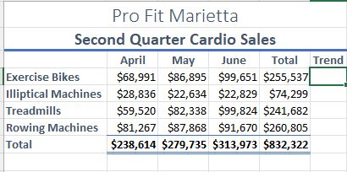

My worksheet is all formatted. But I can make it look more attractive with a theme. A theme is an established set of colors, fonts, and fills effects that are coordinated together to give a spreadsheet an attractive look. I navigated to the “Page Layout” tab, went to the “Themes” group, and clicked on “Retrospect”.

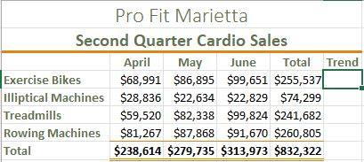

The last step I have is to add a chart to show the monthly sales of cardio equipment by category. A chart is a tool that lets me visually display data in a variety of different charts. I selected the range from cell A3 to cell D7, navigated to the “Insert” tab, went to the “Charts” group, and clicked on “Recommended Charts”. When I clicked on “Recommended Charts”, I got a “Insert Chart” pop-up window. I clicked on the “Clustered Column Chart” option. A clustered column chart compares values across certain categories. When I clicked on the “Clustered Column Chart” option, I got a clustered column chart on my worksheet. I also got two new tabs at the top of my Excel window Ribbon - “Chart Design” and “Format”. In the “Chart Title” text box, I clicked on it and changed the title from “Chart Title” to “Second Quarter Cardio Sales”. Next, I added a chart style. Chart styles have set colors and backgrounds that give a clear visual representation of data. I selected the chart, navigated to the “Chart Design” tab, went to the “Chart Styles” group, and clicked on “Style 6”. In the “Change Colors” drop-down menu, I’ll select “Color 3”.

My final step was to add a sparkline. A sparkline is a tiny chart in a worksheet cell that provides a visual representation of data. I selected the range from cell B4 to cell D7, navigated to the “Insert” tab, went to the “Sparklines” group, and clicked on the “Line” option. When I clicked on “Line”, I got a “Create Sparklines” pop-up window. In the “Location” Range box, I selected the range from cell F4 to cell F7. This is where I wanted my sparklines to be displayed. When I clicked OK on the “Create Sparklines” pop-up window, my sparklines are displayed from cell F4 to cell F7. I also got a new “Sparkline” tab. In the “Sparkline” tab, I went to the “Show” group and clicked on the “Markers” check box. This will show the visual trend summary for sales of each cardio item over each of the three months. Then, I went to the “Style” group and selected “Sparkline Style Accent 4, Darker 25%” in the second row and fourth style.

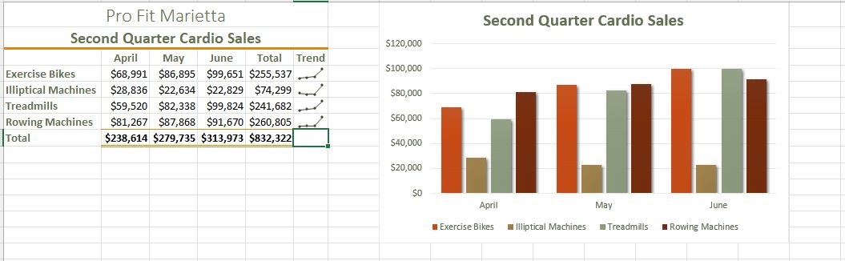

So, this is how I created a worksheet and chart. Hope this tutorial was helpful and I’ll see you in the next one!